**INDIRA GANDHI DELHI TECHNICAL UNIVERSITY FOR WOMEN**

**DEPARTMENT OF**

**ELECTRONICS AND COMMUNICATION**



**REPORT ON**

**Battery Level Indicator Unit**

**Submitted By:**

**ANUKRITI AGARWAL**

**(04301022016)**

**DEEKSHA PANDEY**

**(04701022016)**

**VIDUSHI PANDEY**

**(06001022016)**

**MUSKAN ARORA**

**(06101022016)**

**Under The Guidance of PREETI MEENA PROF. AKASH TAYAL (07001022016)**

**INDEX**

* INTRODUCTION 1
* CIRCUIT COMPONENTS AND DESCRIPTION 3
* CIRCUIT DIAGRAM 4
* METHODOLOGY 5
* TIMELINE 5
* REFERENCES 5

**INTRODUCTION**

Lead acid batteries are the world's most recycled product. These kind of batteries have proved to be the most robust and reliable source of power. Having many advantages, tolerance to overcharging and low internal impedance being a few of them, these batteries have grown in popularity. Each household now a days use these kind of batteries in the form of inverter batteries, automobile batteries etc. Other applications include High current drain applications, submarines etc. Thus it is advantageous to use these kinds of batteries but their maintenance pose a problem especially in domestic domain. The main problems associated with the maintenance are decrement in water level of the battery, decrease in battery output and the wearing out of lead plates. The solution to these problems are proposed in our project BATTERY LEVEL INDICATOR UNIT. The following aspects are taken care in the assessment system.  
  
1. WATER LEVEL INDICATOR- The water level of a lead acid battery determines various aspects of its proper working such as the level of current that can be drawn from a battery depends upon the level of water it has. Also, a low water level means the lead plates may warp and short out or crumble. In this project we propose to develop a system where a notification will be sent on the mobile phone of the concerned person when water level decreases beyond a certain level. The water can b refilled thereafter. The timely refilling of water will ensure the proper functioning of the battery.  
  
2. BATTERY LEVEL INDICATOR- The output of a battery may decrease due to many causes. When the level of battery decreases beyond a certain level irregularities in the behaviour of inverter arises. The proposed assessment system indicates the actual level of battery and displays it by lighting up leds. The number of leds that light up are proportional to the level of battery. Just by looking at the the led indicator one gets the information about the level of battery and take the required action.  
  
3. LEAD PLATE DAMAGE INDICATOR- The lead plates may wear out due to improper maintenance of the battery. Once damaged the battery has to be replaced by a new one. The battery assessment system indicates the damage in lead plates using the same led indicator as used in the battery level indicator. No led is lit in such a condition and thus the user gets to know that its time to replace the battery.

**CIRCUIT COMPONENTS AND DESCRIPTION**

1) LM3914 IC - It is an integrated circuit designed by a national semiconductor and used to operate display that visually show the magnitude of an analog signal. One LM3914 can drive upto 10 LEDs, LCD's or vacuum florescent that display on its output.  
2) SPST switch - (single power single throw) it is a type of switch that only has a single input and can connect only to one output.  
3) LED-10  
4) resistor- there are some resistors of 18k,4.7k,56k.  
5) potentiometer- A potentiometer is a three terminal resistor with a sliding or rotating contact that forms an adjustable voltage device, and we use potentiometer of 10k.  
6) 12 battery  
7) some connecting wires.

8) GSM modem - It is used to send information collected from GPS module along with other details to a specific mobile number.  
9) GPS module - It receive information from satellites regarding the position of the place where accident has occurred.

**LM3914 FEATURES**

* Internal voltage reference from 1.2 to 12v DC.
* Programmable output current 2mA to 30mA.
* LED driver outputs are current regulated.
* No multiplexing interaction between outputs.
* It supports wide range of temperature from 0 to 70 degree Celsius.
* For bar graph display – connect 9th pin of IC to the supply
* For dot display – leave the 9th pin of IC

We can also connect different colour leds to indicate the status. Connect D1 to D3 green LED’s which indicates shut down stage of your battery and use D7-D10 red colour LED’s which indicates 70 to 100 percentage of the battery and use yellow colour for remaining.

**CIRCUIT DIAGRAM**

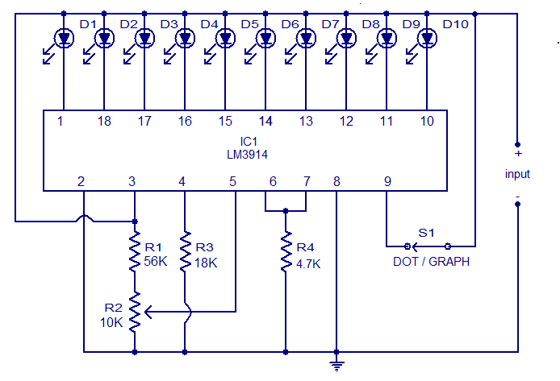

**Battery level indicator circuit using LM3914**

**METHODOLOGY**

The battery level indicator consists to LEDs and IC 3914 along with push buttons.

The no. Of LEDs glowing indicates the level at which battery is charged or the current that it supplies at that instant.

The positive and negative terminals are connected on breadboard to complete the circuit.

And if plates of battery are damaged then no led will glow as the battery will not be able to generate any voltage or current. This will explain the user to repair or replace the existing battery.

A GSM module is used to send a message at user's mobile to intimate the user to refill battery (fill in water in case of water batteries).

This gives an easy mechanism to know the current condition of battery and also eradicates the problem of car battery failure or inverter battery failure due to lack of charging. With these basic circuit the voltage generated by battery can be checked.

Here 10 LEDs are used that are connected along pins of IC on the output terminals and push button on the other side of IC. When push button is pressed then entire sequence of LEDs will glow. For instance if on giving voltage from battery 4 Led is glowing then by pressing push button first 4 LEDs will glow stating that battery is 40% charged.

**TIMELINE**

* Project survey-15 days
* Report-4 days
* Markey survey and making-10 days
* Testing-5 days

**REFERENCES**

**1.** [*http://www.electronicshub.org/*](http://www.electronicshub.org/)

**2.** [*http://www.electronicsforu.com/*](http://www.electronicsforu.com/)

**3.** [*http://www.circuitstoday.com/*](http://www.circuitstoday.com/)

**4.**[*http://www.circuitsgallery.com/*](http://www.circuitsgallery.com/)